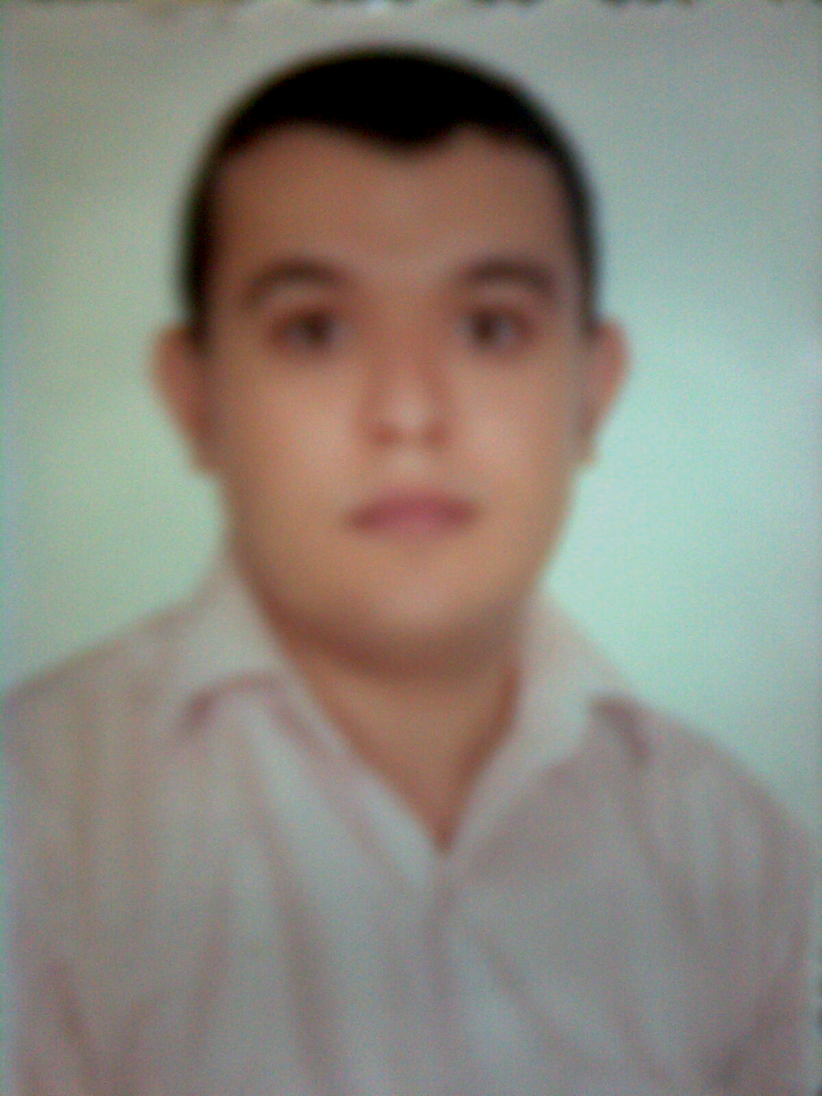
Department of cardiothoracic surgery , College of Medicine, Assiut University Hospital, Assiut,  Egypt  PO Box: 71111 | Phone 002-088-2413773  Fax 002-088-23333277  Mob: 002-01008332462  Email:moha82@ymail.com

Mohammed Mahmoud Ah. Moustafa , MBBCh, MSc
CURRENT POST | Lecturer of cardiothoracic surgery , Assiut University Hospital, Assiut, Egypt from 21/01/2014 .
EDUCATION and Medical licences | Medical Licences:  Egyptian medical licence; Number: 172679
  Degree (year) | Institution | Country
  MSc in (2009) general surgery  Very Good | Assiut University, College  Of Medicine, Assiut. | Egypt
  MBBCh (2004).  excellent | Assiut University, College  Of Medicine, Assiut. | Egypt
POSTS HELD
  Year | Position | Institute/s
  1/6/2009 | Assistant lecturer  Cardiothoracic surgery | Assiut University Hospital,  Egypt.
  1/3/2006 to 4/3/2009 | Resident  Cardiothoracic surgery | Assiut University Hospital,  Egypt.
  1/3/2005 to 28/2/2006 | House officer  (Intern) | Assiut University Hospital,  Egypt.
CLINICAL EXPERIENCE | - Currently, I am first surgeon in open heart surgery ( valve surgery , congenital heart surgery ),first assistant in CABG , also , I have performed as the main surgeon 26 cases of aortic & mitral valve replacement , cardiac operations for simple congenital heart defects ( secundum ASD , PDA),two case VSD.I harvest about 50 saphenous viens,70 internal mammary artery. I have training for clinical perfusion ,and postoperative cardiac intensive care.  I have spent five months in Pediatric cardiothoracic surgery unit in our university  ,We have 2 missions by American cardiothoracic surgeon MR. William Novik about 20 complex cases in each mission .I have assisted in many cases one was ROSS operation.  - First assistant in 15 cases of open heart surgery from thoracotomy (ASD.MVR) with me do femoral cannulation in 5 cases.  - 2 cases of redo valve cardiac surgeon and 8 cases as first assistant.  - I have 9 year experience in thoracic surgery : I perform as the main surgeon the following thoracic operations ( pulmonary resection , lung decortication , chest wall reconstruction , congenital diaphragmatic hernias & achalasia of the esophagus ), also I have assissted in cases of mediastinal tumors and cancer esophagus.  I have 9 year experience of performing rigid bronchoscopy in Assuit university hospital , Egypt .  - I am part of trauma team in Assuit university hospital for 9 years during which I have dealt with various cases of thoracic trauma ( blunt and penetrating ).
POST GRADUATE EDUCATION | - MSc (2009) in general surgery clinical exam and thesis titled [TRACHEO- ESOPHAGEAL FISTULA ONE OR TWO STAGE SURGICAL MANAGEMENT ]
- MD (2011) in cardiothoracic surgery,the thesis titled on Surgical Resolution of Different levels of left ventricular outflow tract obstruction
REFREES | Ahmed Mohammed Aelminshawy, professor and head of cardiothoracic surgery , head of pediatric cardiothoracic surgery unit ,college of medicine , Assuit university , Egypt .  Cell phone :002-0112743943  Mail : aelminshawy@hotmail.com

